Project Design Phase
Solution Architecture

Date | 12 February 2025
Team ID | LTVIP2026TMIDS80676
Project Name | FreelanceFinder: Discovering Opportunities, Unlocking Potential
Maximum Marks | 4 Marks

Solution Architecture:
The FreelanceFinder platform follows a 3-tier web architecture that connects business requirements with technology solutions. The system is designed to provide a centralized freelancing environment where freelancers, clients, and administrators interact through secure web interfaces.
- Frontend (Presentation Layer):
Built using React.js, HTML, CSS, and JavaScript. Provides role-based dashboards for freelancers, clients, and administrators to register, post projects, submit proposals, and track work.
- Backend (Application Layer):
Developed with Node.js and Express.js. Handles authentication, project management, proposal processing, communication, and work submission through REST APIs.
- Database (Data Layer):
Uses MongoDB to store user profiles, project details, proposals, and submission data securely.

Solution Architecture Diagram:
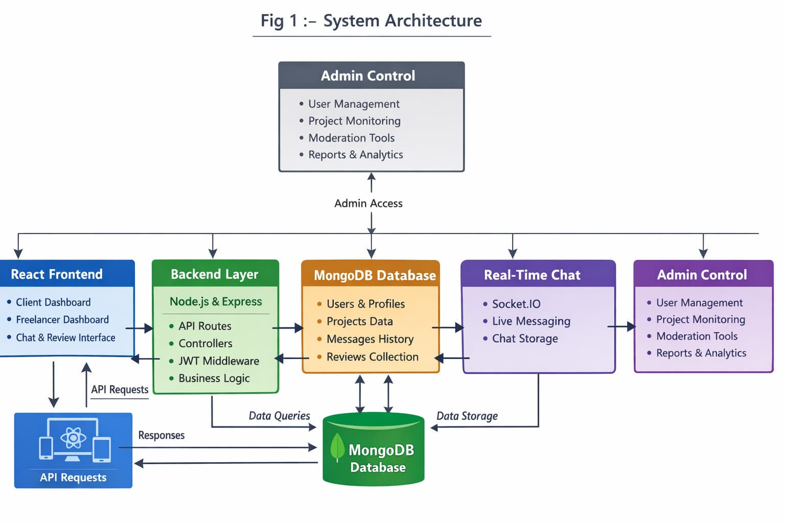 Figure 1: Architecture and data flow of the FreelancingFinder portal

